**The Eiffel Tower**

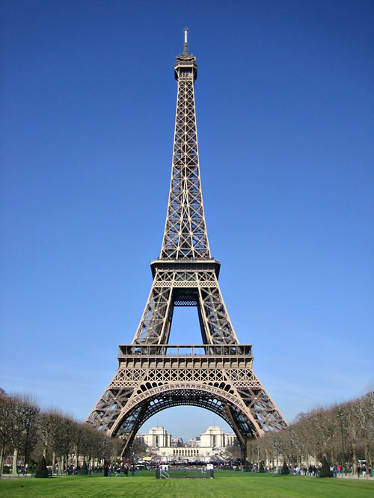

The Eiffel Tower, a symbol of Paris and France, has enjoyed a level of success that no one could have possibly imagined when it was built in 1889. It attracts some 7 million visitors every year and over the decades has become one of the country's most important monuments.